Smart parking

Program :

#define ECHO_PIN1 15

#define TRIG_PIN1 2

#define ECHO_PIN2 5

#define TRIG_PIN2 18

#define ECHO_PIN3 26

#define TRIG_PIN3 27

int LEDPIN1 = 13;

int LEDPIN2 = 12;

int LEDPIN3 = 14;

void setup() {

**Serial**.begin(115200);

  pinMode(LEDPIN1, OUTPUT);

  pinMode(TRIG_PIN1, OUTPUT);

  pinMode(ECHO_PIN1, INPUT);

   pinMode(LEDPIN2, OUTPUT);

  pinMode(TRIG_PIN2, OUTPUT);

  pinMode(ECHO_PIN2, INPUT);

   pinMode(LEDPIN3, OUTPUT);

  pinMode(TRIG_PIN3, OUTPUT);

  pinMode(ECHO_PIN3, INPUT);

}

float readDistance1CM() {

  digitalWrite(TRIG_PIN1, LOW);

  delayMicroseconds(2);

  digitalWrite(TRIG_PIN1, HIGH);

  delayMicroseconds(10);

  digitalWrite(TRIG_PIN1, LOW);

  int duration = pulseIn(ECHO_PIN1, HIGH);

  return duration * 0.034 /2 ;

}

float readDistance2CM() {

  digitalWrite(TRIG_PIN2, LOW);

  delayMicroseconds(2);

  digitalWrite(TRIG_PIN2, HIGH);

  delayMicroseconds(10);

  digitalWrite(TRIG_PIN2, LOW);

  int duration = pulseIn(ECHO_PIN2, HIGH);

  return duration * 0.034 / 2;

}

float readDistance3CM() {

  digitalWrite(TRIG_PIN3, LOW);

  delayMicroseconds(2);

  digitalWrite(TRIG_PIN3, HIGH);

  delayMicroseconds(10);

  digitalWrite(TRIG_PIN3, LOW);

  int duration = pulseIn(ECHO_PIN3, HIGH);

  return duration * 0.034 / 2;

}

Sensor : 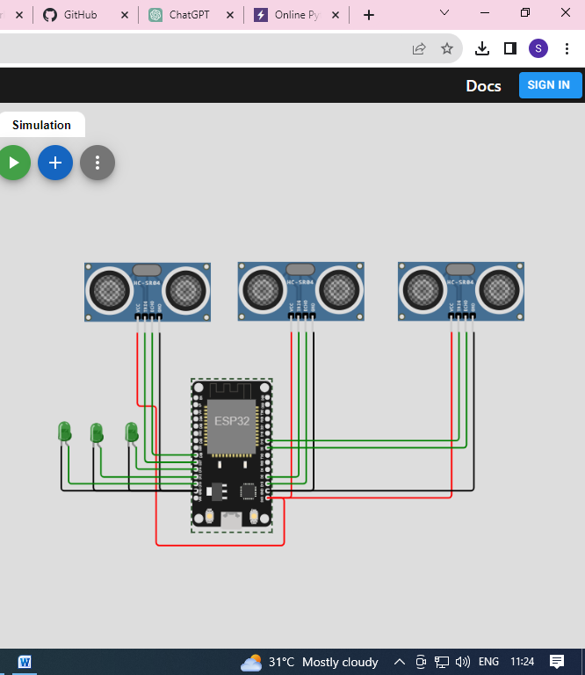

Output :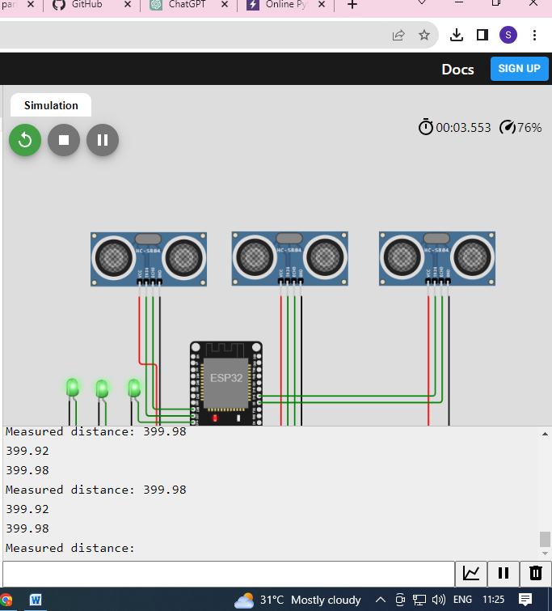

Output 